John Lennon is credited with saying, “Life is what happens to you while you are busy making other plans.” It seems that he was trying to say that the real focus should be more on the life that is happening and less on the other plans because sometimes the other plans are leading us away from the life that we are meant to live.
Along with the thought about the Lennon quote, the word ambition came to my mind. I looked the word up online. Here is what I found:
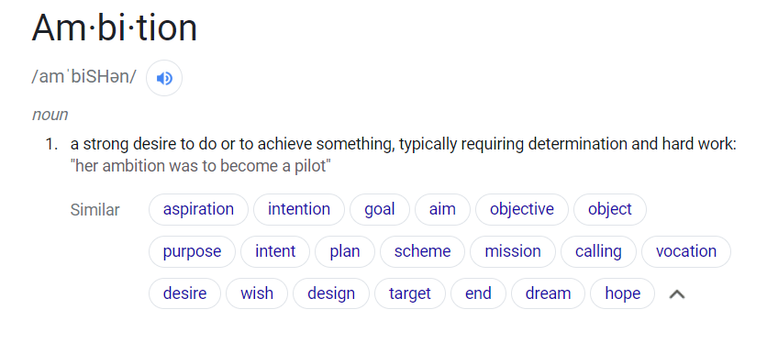
I like how the definition that I found describes ambition as a strong desire to achieve something. It is so strong, that it sometimes leads us to make wrong turns off the path that our lives are meant to follow or to press too hard on the gas pedal and rush down the road faster than we are supposed to. When we do that, we miss out on the people and things that we are quickly passing by. Sometimes we can be so ambitious that we don’t even take time to adequately enjoy the people that are on the ride with us.
After these thoughts were in my mind this morning, I took my son to school. When I was outside, the cold air hit my face. I took a moment to stop and feel the sensation of the frigid air on my skin. I noticed the birds singing and the cold breeze blowing. Of course, my thoughts quickly returned to the too many things that are on my mind to do today and I felt the pressure to get started on my to-do list, so I let the moment go.
I think it is important to realize that many of the ambitions that we have may not be realized. This can be very humbling and very disturbing to us because the view we have of ourselves is so tied up with our ambitions. What do we do with that realization? Perhaps the best thing to do is stop, take a break, say a little prayer, and mean it. “Your Kingdom Come, (Not my kingdom). Your will be done, (not my will)”, then ask God to sort through our ambitions to see which ones are worthy of our energy and effort and which ones are not. Perhaps we should ease up on the gas pedal. Notice the things and the people that we are passing by on the outside and do a better job of relating to and caring for the people that are on the ride with me.

